LAB 2 Practice:

1. Write a program to print the output of the series, 1 + x + 2x + 3x... and 1 + x/2 + 2x/3 + 3x/4.. (use double for output) till n numbers, where n is coefficient of x.

2. Write a program to get four integer variables as input and do the check whether each of them is divisible by 2 and 3 or it is divisible by 5. If it is true and if more than one value is satisfying the condition then select the largest of the numbers which satisfy the condition and pass that particular value by reference to a function refer, multiply it by 10 and print the variable value in the main.

3. Write a program to print the nearest integer value of corresponding float value given by the user, without using any library function.

4. Write a program using function to indicate whether a given number is divisible by 5 or 6, if divisible by 5 multiply it to 6 or vice versa and return the value, indicate the divisibility also (which has to be calculated in the function).

1.

#include<stdio.h>

int main()

{

    double n,sum,x=1;

    sum=1;

    printf("Enter n: ");

    scanf("%lf",&n);

    for(int i=0;i<n;i++){

    sum+=(i\*x);

    }

    printf("%lf\n",sum);

    double sum2=1;

    for(int i=0;i<n;i++){

        sum2+=((i/(i+1))\*x);

    }

    printf("%lf",sum2);

    return 0;

}

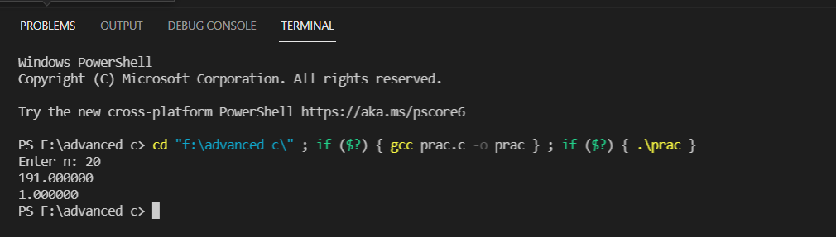

2.

#include <stdio.h>

int divisible(int[], int);

int divisible(int arr[], int t)

{

    int max = 0;

    for (int i = 0; i < t; i++)

    {

        if (arr[i] > max)

        {

            max = arr[i];

        }

    }

    return max;

}

int main()

{

    int a[4];

    int l[4] = {0, 0, 0, 0};

    int t = 0, max=-5;

    for (int i = 0; i < 4; i++)

    {

        scanf("%d \n", &a[i]);

    }

for(int i=0;i<4;i++){

        if (a[i] % 2 == 0 && a[i] % 3 == 0 && a[i] % 5 == 0)

        {

            l[t] = a[i];

            t++;

        }

    }

    if (t >= 1)

    {

        max = divisible(l, t);

    }

    else{

        max=l[0];

    }

    printf("%d\n", max);

    return 0;

}

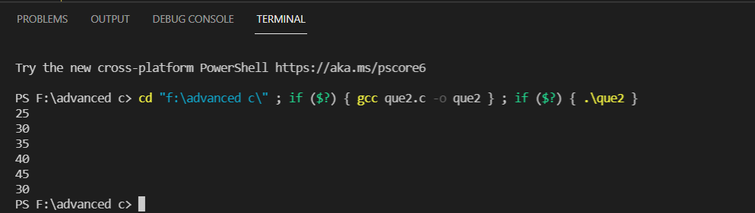

3.

#include<stdio.h>

int main()

{

    float d;

    scanf("%f",&d);

    d=d+ 0.5;

    printf("%d", (int)d);

    return 0;

}

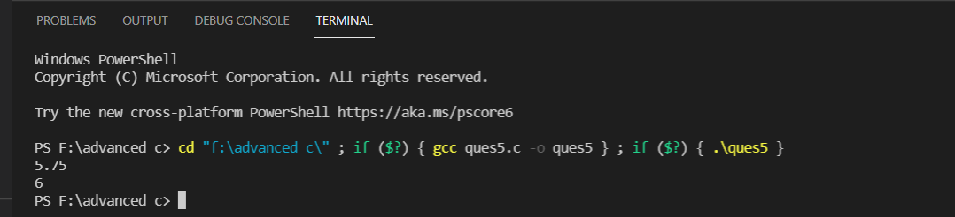

4.

#include<stdio.h>

void divisibility(int num, int \*nu5, int \*nu6){

if(num%5==0){

    \*nu5=1;

}

if(num%6==0){

    \*nu6=1;

}

if(num%30==0){

    \*nu5=2,\*nu6=2;

}

}

int main()

{

    int num=30;

    scanf("%d",&num);

    int div5, div6;

    divisibility(num,&div5,&div6);

    if (div5==1){

        printf("%d \t %d",num\*6, div5);

    }

    if (div6==1){

        printf("%d \t %d",num\*5,div6);

    }

    if (div5==2 && div6==2){

        printf("%d \t %d",num\*10,30);

    }

    return 1;

}

